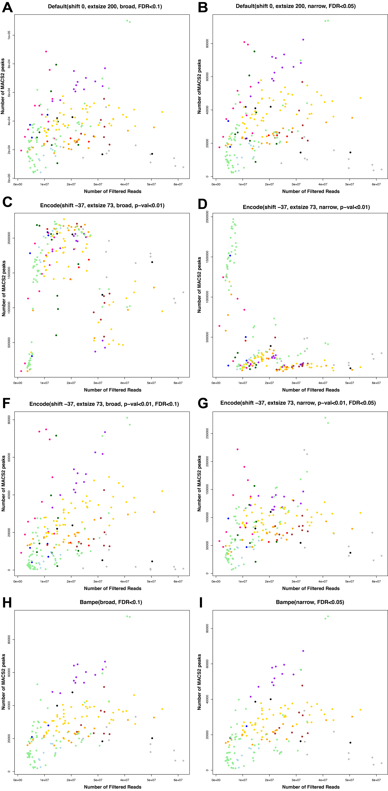

**S1 Figure**. Number of peaks vs. number of filtered reads. MACS2 peaks are generated under **(A,B)** default parameter setting with broad and narrow mode, **(C,D)** ENCODE parameters with p-value cutoff only, **(E,F)** ENCODE parameters with the default q-value restrictions (0.1 for broad, 0.05 for narrow), and **(H,I)** BAMPE parameters.

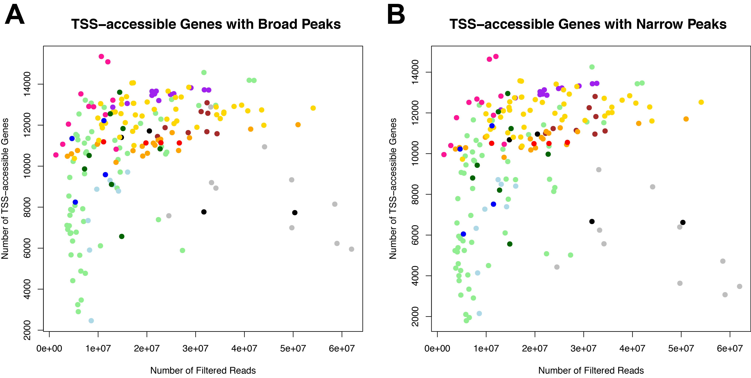

**S2 Figure.** Number of TSS-accessible genes vs. number of filtered reads. Each color represents each study. Left panel is generated from *broad* peaks and right panel is from *narrow* peaks.



**S3 Figure**. Fraction of peaks with fold-change of read signals below 2. Left panel is from *narrow* peaks and right panel is from *broad* peaks.



**S4 Figure**. Distribution of q-values of lost peaks at 90% sampling. Q-values are transformed to negative log scale. Y-axis is the relative frequency.

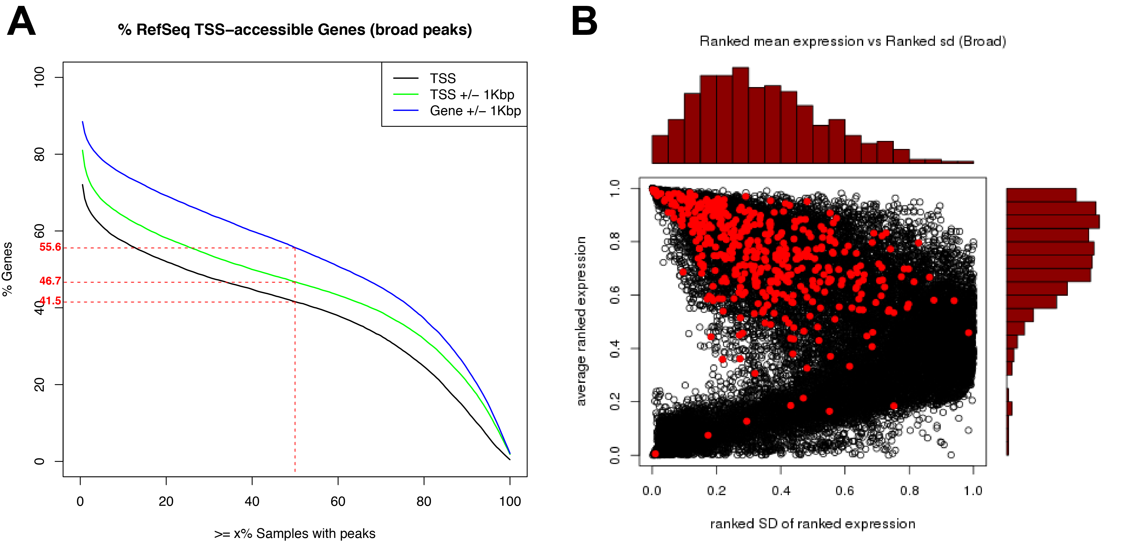

**S5 Figure**. Related to Figure 4, with broad peaks: (A)Probability of a gene exhibiting a TSS-accessible peak across 193 samples. Black line is for peaks overlapping with TSS, green line is for peaks overlapping in TSS regions, and blue line is for peaks overlapping with genic regions (+/- 1kb of gene body). 50% or more samples have peaks in roughly 55% of genic regions in RefSeq. (B) Ranked mean expression (y-axis) of genes across compared to their variation in expression (SD, x-axis). TSS-accessible genes are highlighted in blue. The histogram on the top shows the distribution of SDs for the subset of 438 TSS-accessible genes, and the histogram on the right shows the distribution of ranked expression.



**S6 Figure**. Number of TSS-accessible genes called after applying 10% downsampling strategy. A gene is called TSS-accessible if called in more than 9 replicates.

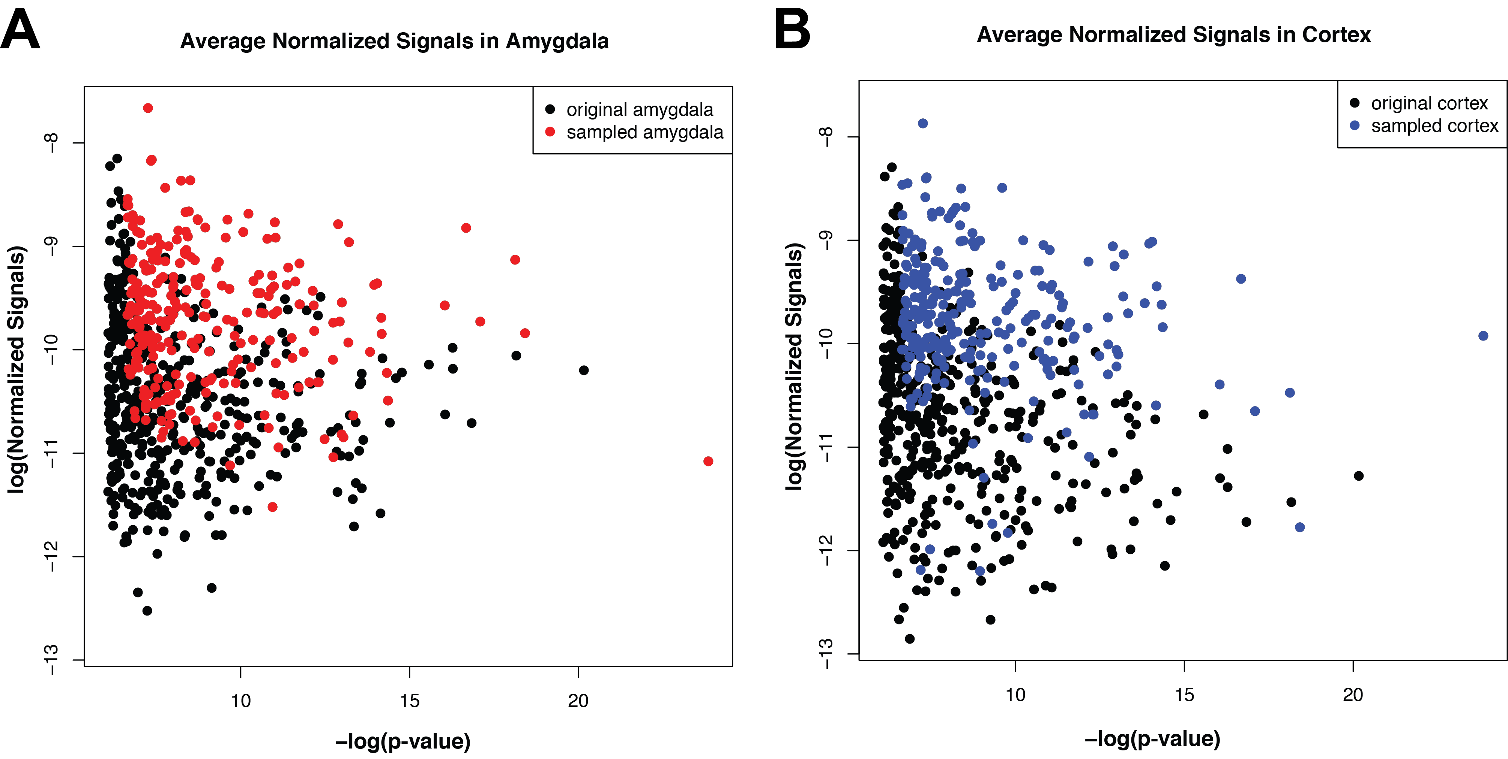

**S7 Figure**. Normalized signals vs. p-value of amygdala and cortex